**Assignment No-2**

**1. Working with java.lang.Boolean**

**a.** Explore the [Java API documentation for java.lang.Boolean](https://docs.oracle.com/javase/8/docs/api/java/lang/Boolean.html) and observe its modifiers and super types.

**b.** Declare a method-local variable status of type boolean with the value true and convert it to a String using the toString method. (Hint: Use Boolean.toString(Boolean) ).

**c.** Declare a method-local variable strStatus of type String with the value "true" and convert it to a boolean using the parseBoolean method. (Hint: Use Boolean.parseBoolean(String)).

**d.** Declare a method-local variable strStatus of type String with the value "1" or "0" and attempt to convert it to a boolean. (Hint: parseBoolean method will not work as expected with "1" or "0").

**e.** Declare a method-local variable status of type boolean with the value true and convert it to the corresponding wrapper class using Boolean.valueOf(). (Hint: Use Boolean.valueOf(boolean)).

**f.** Declare a method-local variable strStatus of type String with the value "true" and convert it to the corresponding wrapper class using Boolean.valueOf(). (Hint: Use Boolean.valueOf(String)).

**g.** Experiment with converting a boolean value into other primitive types or vice versa and observe the results.

Ans: b. **public** **class** Datatypedemo1 {

**public** **static** **void** main(String[] args) {

**boolean** status=**true**;

String statusasString= Boolean.*toString*(status);

System.***out***.println(" string asString:" +statusasString);

}}

c. **public** **class** Datatypedemo2 {

**public** **static** **void** main(String[] args) {

String strstatus="true";

**boolean** status = Boolean.*parseBoolean*(strstatus);

System.***out***.println("str status is"+strstatus);

}}

d. **public** **class** Datatype3 {

**public** **static** **void** main(String[] args) {

String strstatus="1";

String strstatus1="0";

**boolean** status = "1".equals(strstatus);

**boolean** status1="0".equals(strstatus1);

System.***out***.println("status is" +strstatus);

System.***out***.println("status1 is"+strstatus1);

} }

e. **public** **class** Datatype4 {

**public** **static** **void** main(String[] args) {

**boolean** status=**true**;

Boolean.valueOf(status);

System.out.println("status is" +status);}}

f. **public** **static** **void** main(String[] args) {

String strstatus="true";

Boolean.*valueOf*(strstatus);

System.***out***.println(strstatus);

}

}

**2. Working with java.lang.Byte**

**a.** Explore the [Java API documentation for java.lang.Byte](https://docs.oracle.com/javase/8/docs/api/java/lang/Byte.html) and observe its modifiers and super types.

**b.** Write a program to test how many bytes are used to represent a byte value using the BYTES field. (Hint: Use Byte.BYTES).

**c.** Write a program to find the minimum and maximum values of byte using the MIN_VALUE and MAX_VALUE fields. (Hint: Use Byte.MIN_VALUE and Byte.MAX_VALUE).

**d.** Declare a method-local variable number of type byte with some value and convert it to a String using the toString method. (Hint: Use Byte.toString(byte)).

**e.** Declare a method-local variable strNumber of type String with some value and convert it to a byte value using the parseByte method. (Hint: Use Byte.parseByte(String)).

**f.** Declare a method-local variable strNumber of type String with the value "Ab12Cd3" and attempt to convert it to a byte value. (Hint: parseByte method will throw a NumberFormatException).

**g.** Declare a method-local variable number of type byte with some value and convert it to the corresponding wrapper class using Byte.valueOf(). (Hint: Use Byte.valueOf(byte)).

**h.** Declare a method-local variable strNumber of type String with some byte value and convert it to the corresponding wrapper class using Byte.valueOf(). (Hint: Use Byte.valueOf(String)).

**i.** Experiment with converting a byte value into other primitive types or vice versa and observe the results.

**Ans: b]**

public class Datatype5 {

public static void main(String[] args) {

System.*out*.println("byte size is"+Byte.*BYTES*);

}

}

**c] public class Datatype6 {**

public static void main(String[] args) {

System.*out*.println("min size of byte is" +Byte.*MAX_VALUE*);

System.*out*.println("max size of byte is"+Byte.*MIN_VALUE*);}}

D]

**public** **class** Datatype7 {

**public** **static** **void** main(String[] args) {

**byte** number=4;

String numberAsString = Byte.*toString*(number);

System.***out***.println("string is"+number);}}

E]

**public** **static** **void** main(String[] args) {

String strnumber="6";

Byte AsString=Byte.*parseByte*(strnumber);

System.***out***.println("convert byte to string" +strnumber);

}}

F]

**public** **class** Datatype11 {

**public** **static** **void** main1(String[] args) {

String strnumber ="Ab12Cd3" ;

**byte** string=Byte.*parseByte*(strnumber);

}}

G]

**public** **class** Datatype11 {

**public** **static** **void** main2(String[] args) {

**byte** number =100;

System.***out***.println("byte number is"+Byte.*valueOf*(number));

}}

H]

**public** **class** Datatype11 {

**public** **static** **void** main(String[] args) {

String strnumber="3";

**byte** number=Byte.*valueOf*(strnumber);

System.***out***.println("string is" +strnumber);

}}

**3. Working with java.lang.Short**

**a.** Explore the [Java API documentation for java.lang.Short](https://docs.oracle.com/javase/8/docs/api/java/lang/Short.html) and observe its modifiers and super types.

**b.** Write a program to test how many bytes are used to represent a short value using the BYTES field. (Hint: Use Short.BYTES).

**c.** Write a program to find the minimum and maximum values of short using the MIN_VALUE and MAX_VALUE fields. (Hint: Use Short.MIN_VALUE and Short.MAX_VALUE).

**d.** Declare a method-local variable number of type short with some value and convert it to a String using the toString method. (Hint: Use Short.toString(short)).

**e.** Declare a method-local variable strNumber of type String with some value and convert it to a short value using the parseShort method. (Hint: Use Short.parseShort(String)).

**f.** Declare a method-local variable strNumber of type String with the value "Ab12Cd3" and attempt to convert it to a short value. (Hint: parseShort method will throw a NumberFormatException).

**g.** Declare a method-local variable number of type short with some value and convert it to the corresponding wrapper class using Short.valueOf(). (Hint: Use Short.valueOf(short)).

**h.** Declare a method-local variable strNumber of type String with some short value and convert it to the corresponding wrapper class using Short.valueOf(). (Hint: Use Short.valueOf(String)).

**i.** Experiment with converting a short value into other primitive types or vice versa and observe the results.

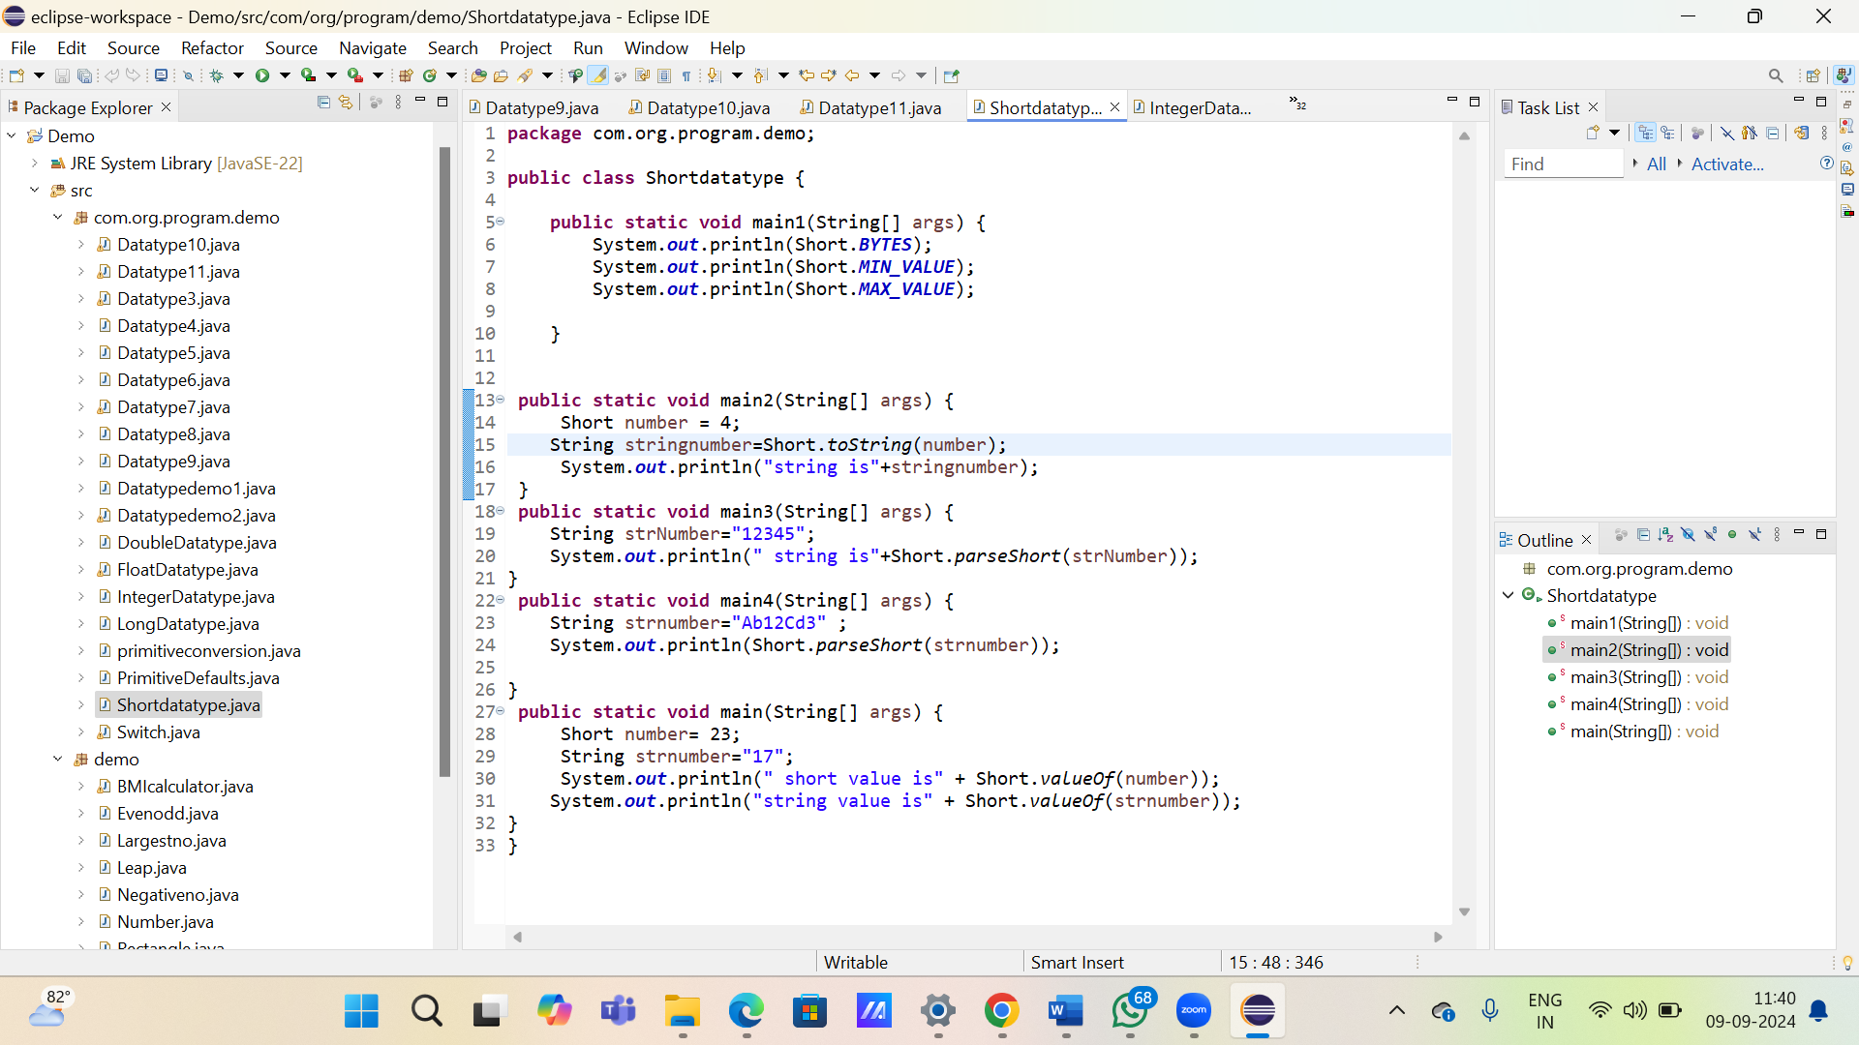

**4. Working with java.lang.Integer**

**a.** Explore the [Java API documentation for java.lang.Integer](https://docs.oracle.com/javase/8/docs/api/java/lang/Integer.html) and observe its modifiers and super types.

**b.** Write a program to test how many bytes are used to represent an int value using the BYTES field. (Hint: Use Integer.BYTES).

**c.** Write a program to find the minimum and maximum values of int using the MIN_VALUE and MAX_VALUE fields. (Hint: Use Integer.MIN_VALUE and Integer.MAX_VALUE).

**d.** Declare a method-local variable number of type int with some value and convert it to a String using the toString method. (Hint: Use Integer.toString(int)).

**e.** Declare a method-local variable strNumber of type String with some value and convert it to an int value using the parseInt method. (Hint: Use Integer.parseInt(String)).

**f.** Declare a method-local variable strNumber of type String with the value "Ab12Cd3" and attempt to convert it to an int value. (Hint: parseInt method will throw a NumberFormatException).

**g.** Declare a method-local variable number of type int with some value and convert it to the corresponding wrapper class using Integer.valueOf(). (Hint: Use Integer.valueOf(int)).

**h.** Declare a method-local variable strNumber of type String with some integer value and convert it to the corresponding wrapper class using Integer.valueOf(). (Hint: Use Integer.valueOf(String)).

**i.** Declare two integer variables with values 10 and 20, and add them using a method from the Integer class. (Hint: Use Integer.sum(int, int)).

**j.** Declare two integer variables with values 10 and 20, and find the minimum and maximum values using the Integer class. (Hint: Use Integer.min(int, int) and Integer.max(int, int)).

**k.** Declare an integer variable with the value 7. Convert it to binary, octal, and hexadecimal strings using methods from the Integer class. (Hint: Use Integer.toBinaryString(int), Integer.toOctalString(int), and Integer.toHexString(int)).

**l.** Experiment with converting an int value into other primitive types or vice versa and observe the results.

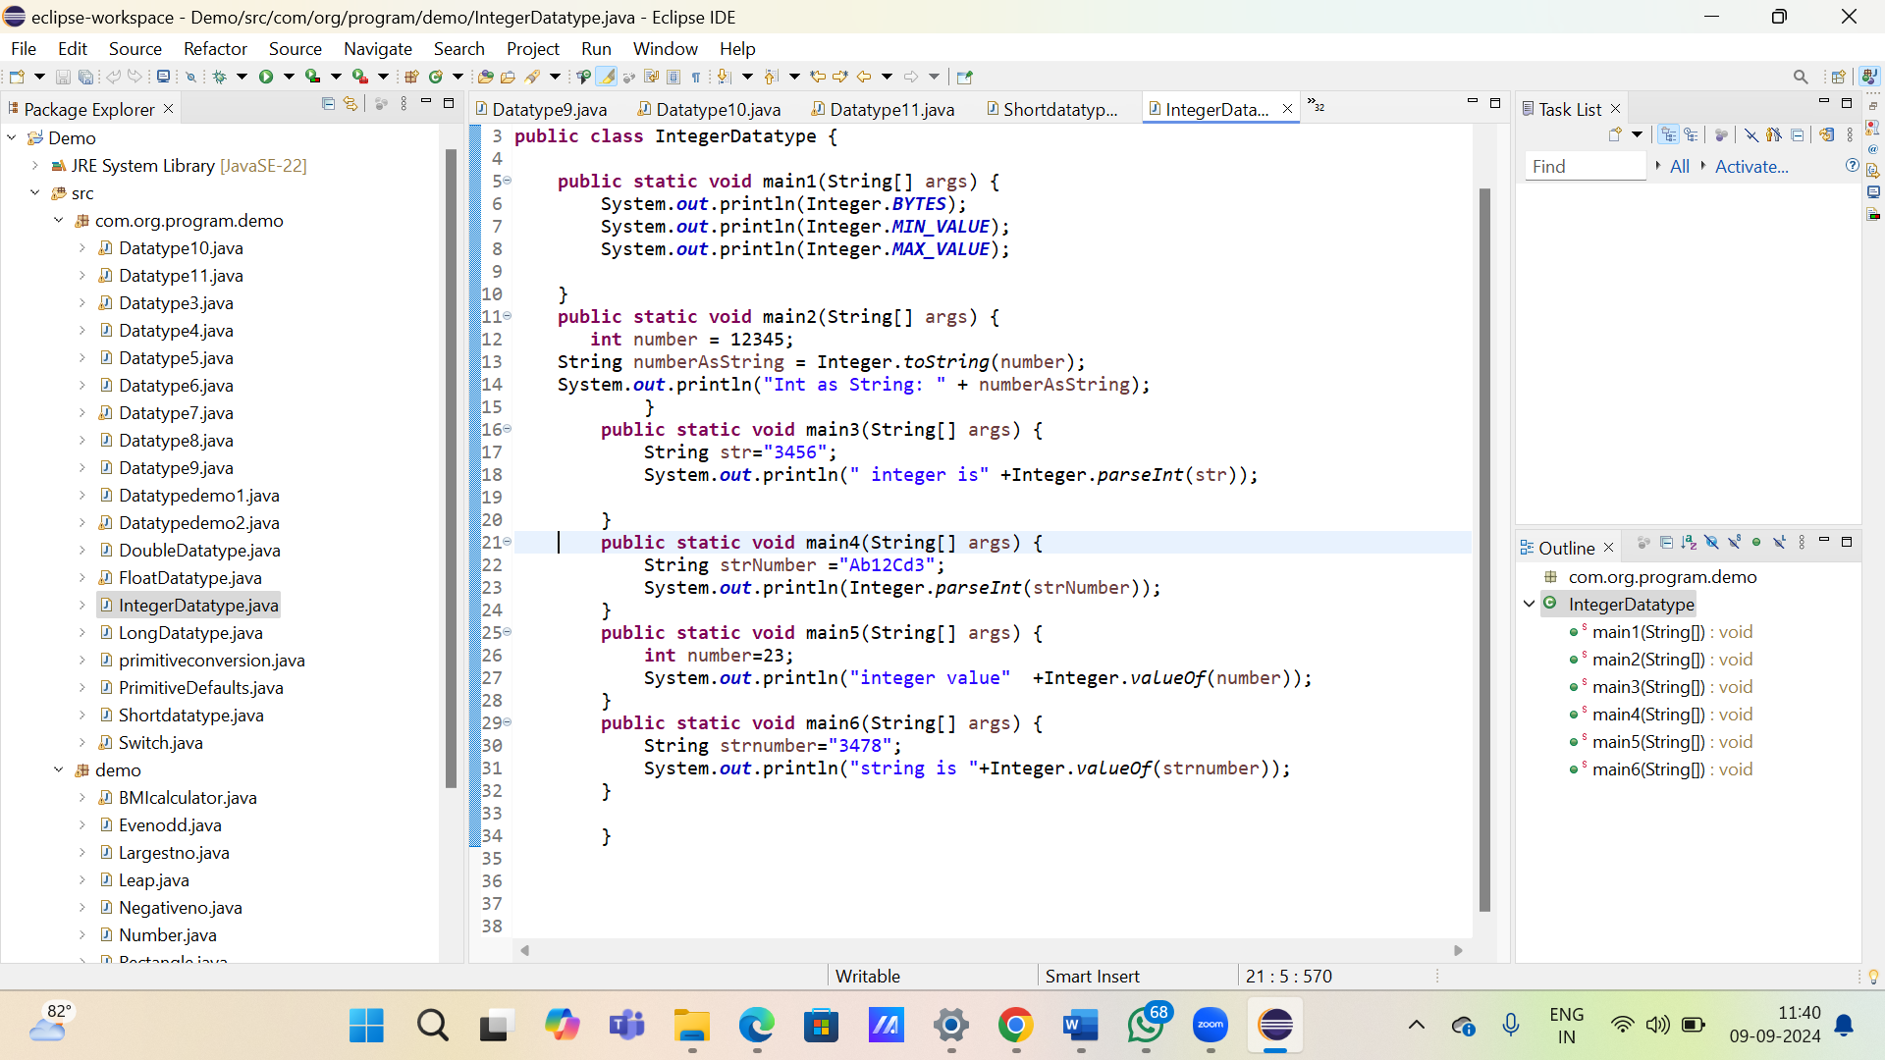

5. Working with java.lang.Long

a. Explore the [Java API documentation for java.lang.Long](https://docs.oracle.com/javase/8/docs/api/java/lang/Long.html) and observe its modifiers and super types.

b. Write a program to test how many bytes are used to represent a long value using the BYTES field. (Hint: Use Long.BYTES).

c. Write a program to find the minimum and maximum values of long using the MIN_VALUE and MAX_VALUE fields. (Hint: Use Long.MIN_VALUE and Long.MAX_VALUE).

d. Declare a method-local variable number of type long with some value and convert it to a String using the toString method. (Hint: Use Long.toString(long)).

e. Declare a method-local variable strNumber of type String with some value and convert it to a long value using the parseLong method. (Hint: Use Long.parseLong(String)).

f. Declare a method-local variable strNumber of type String with the value "Ab12Cd3" and attempt to convert it to a long value. (Hint: parseLong method will throw a NumberFormatException).

g. Declare a method-local variable number of type long with some value and convert it to the corresponding wrapper class using Long.valueOf(). (Hint: Use Long.valueOf(long)).

h. Declare a method-local variable strNumber of type String with some long value and convert it to the corresponding wrapper class using Long.valueOf(). (Hint: Use Long.valueOf(String)).

i. Declare two long variables with values 1123 and 9845, and add them using a method from the Long class. (Hint: Use Long.sum(long, long)).

j. Declare two long variables with values 1122 and 5566, and find the minimum and maximum values using the Long class. (Hint: Use Long.min(long, long) and Long.max(long, long)).

k. Declare a long variable with the value 7. Convert it to binary, octal, and hexadecimal strings using methods from the Long class. (Hint: Use Long.toBinaryString(long), Long.toOctalString(long), and Long.toHexString(long)).

l. Experiment with converting a long value into other primitive types or vice versa and observe the results.

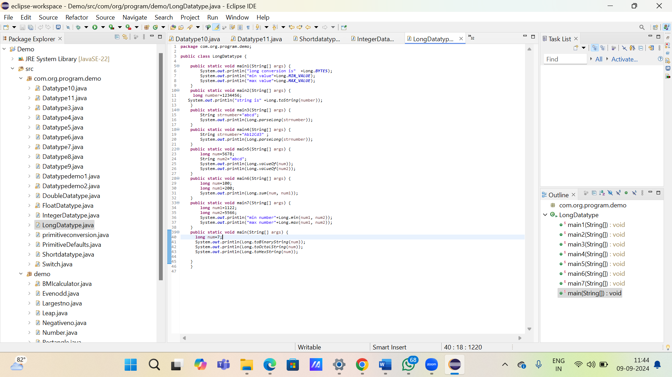

**a.** Explore the [Java API documentation for java.lang.Float](https://docs.oracle.com/javase/8/docs/api/java/lang/Float.html) and observe its modifiers and super types.

**b.** Write a program to test how many bytes are used to represent a float value using the BYTES field. (Hint: Use Float.BYTES).

**c.** Write a program to find the minimum and maximum values of float using the MIN_VALUE and MAX_VALUE fields. (Hint: Use Float.MIN_VALUE and Float.MAX_VALUE).

**d.** Declare a method-local variable number of type float with some value and convert it to a String using the toString method. (Hint: Use Float.toString(float)).

**e.** Declare a method-local variable strNumber of type String with some value and convert it to a float value using the parseFloat method. (Hint: Use Float.parseFloat(String)).

**f.** Declare a method-local variable strNumber of type String with the value "Ab12Cd3" and attempt to convert it to a float value. (Hint: parseFloat method will throw a NumberFormatException).

**g.** Declare a method-local variable number of type float with some value and convert it to the corresponding wrapper class using Float.valueOf(). (Hint: Use Float.valueOf(float)).

**h.** Declare a method-local variable strNumber of type String with some float value and convert it to the corresponding wrapper class using Float.valueOf(). (Hint: Use Float.valueOf(String)).

**i.** Declare two float variables with values 112.3 and 984.5, and add them using a method from the Float class. (Hint: Use Float.sum(float, float)).

**j.** Declare two float variables with values 112.2 and 556.6, and find the minimum and maximum values using the Float class. (Hint: Use Float.min(float, float) and Float.max(float, float)).

**k.** Declare a float variable with the value -25.0f. Find the square root of this value. (Hint: Use Math.sqrt() method).

**l.** Declare two float variables with the same value, 0.0f, and divide them. (Hint: Observe the result and any special floating-point behavior).

**m.** Experiment with converting a float value into other primitive types or vice versa and observe the results.

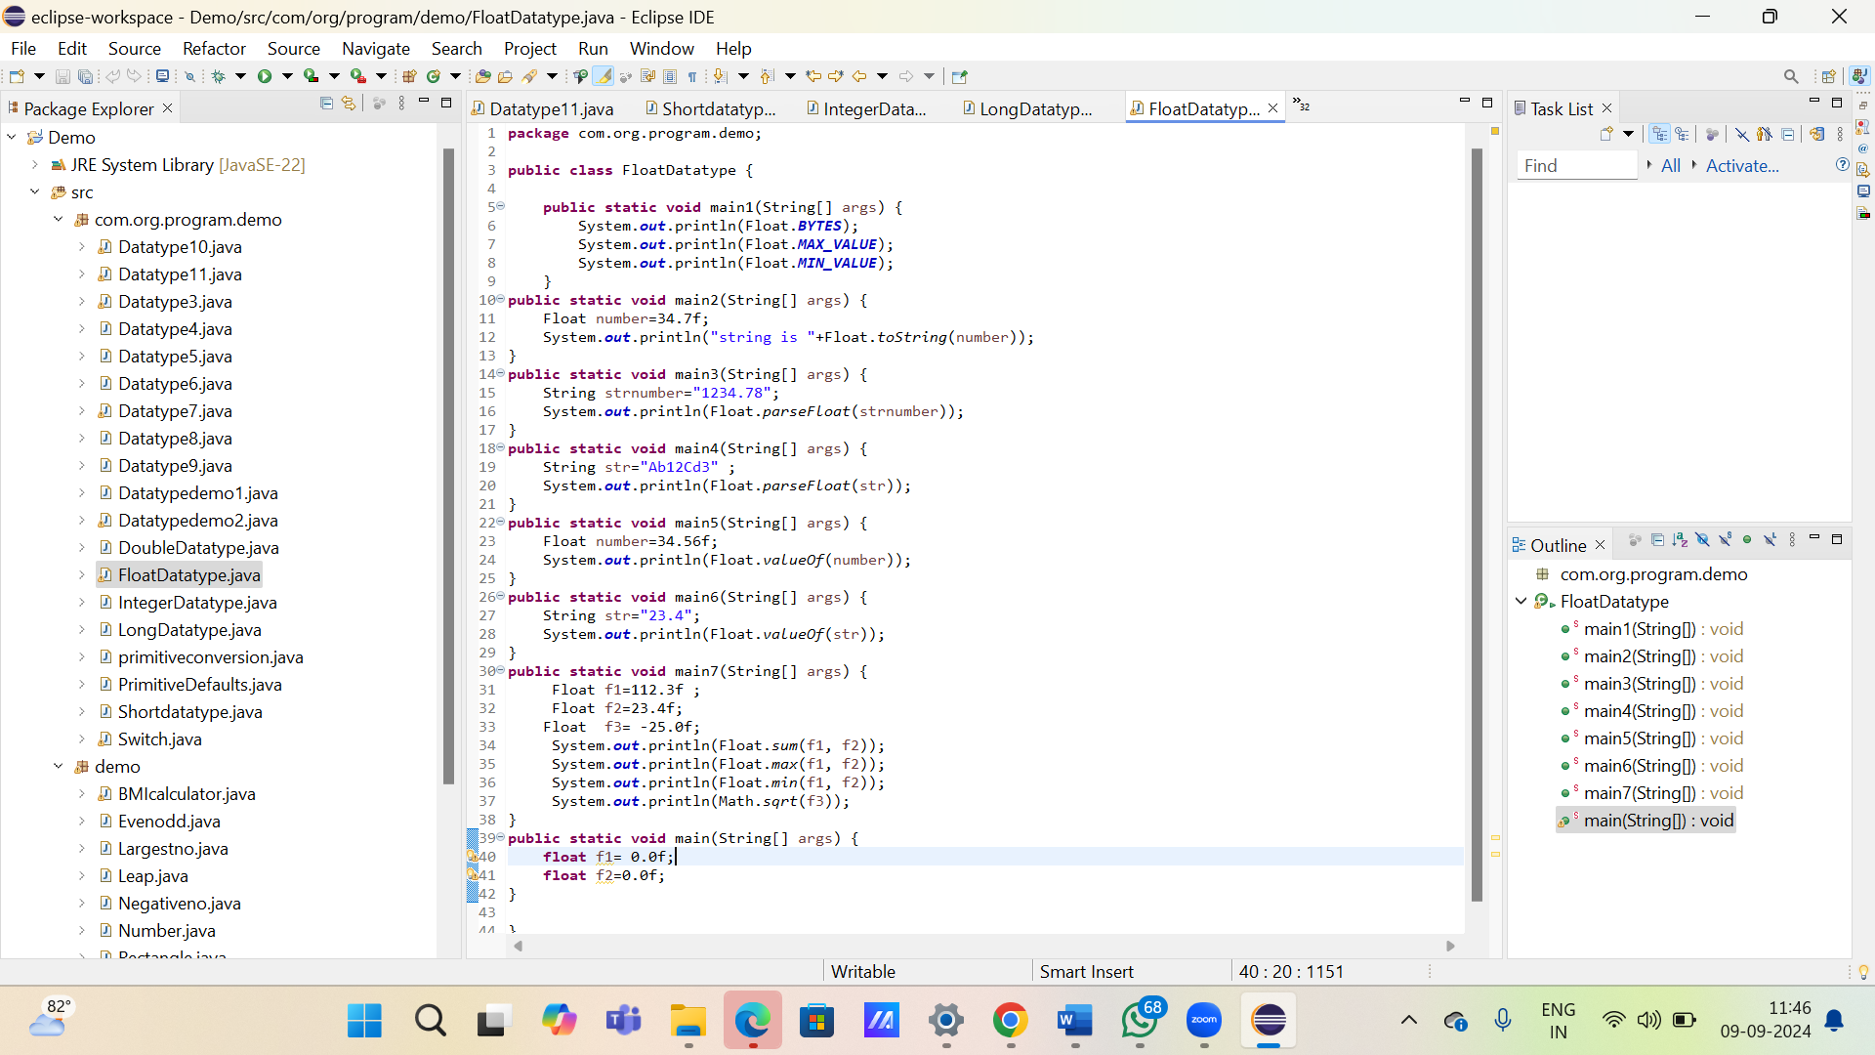

**7. Working with java.lang.Double**

**a.** Explore the [Java API documentation for java.lang.Double](https://docs.oracle.com/javase/8/docs/api/java/lang/Double.html) and observe its modifiers and super types.

**b.** Write a program to test how many bytes are used to represent a double value using the BYTES field. (Hint: Use Double.BYTES).

**c.** Write a program to find the minimum and maximum values of double using the MIN_VALUE and MAX_VALUE fields. (Hint: Use Double.MIN_VALUE and Double.MAX_VALUE).

**d.** Declare a method-local variable number of type double with some value and convert it to a String using the toString method. (Hint: Use Double.toString(double)).

**e.** Declare a method-local variable strNumber of type String with some value and convert it to a double value using the parseDouble method. (Hint: Use Double.parseDouble(String)).

**f.** Declare a method-local variable strNumber of type String with the value "Ab12Cd3" and attempt to convert it to a double value. (Hint: parseDouble method will throw a NumberFormatException).

**g.** Declare a method-local variable number of type double with some value and convert it to the corresponding wrapper class using Double.valueOf(). (Hint: Use Double.valueOf(double)).

**h.** Declare a method-local variable strNumber of type String with some double value and convert it to the corresponding wrapper class using Double.valueOf(). (Hint: Use Double.valueOf(String)).

**i.** Declare two double variables with values 112.3 and 984.5, and add them using a method from the Double class. (Hint: Use Double.sum(double, double)).

**j.** Declare two double variables with values 112.2 and 556.6, and find the minimum and maximum values using the Double class. (Hint: Use Double.min(double, double) and Double.max(double, double)).

**k.** Declare a double variable with the value -25.0. Find the square root of this value. (Hint: Use Math.sqrt() method).

**l.** Declare two double variables with the same value, 0.0, and divide them. (Hint: Observe the result and any special floating-point behavior).

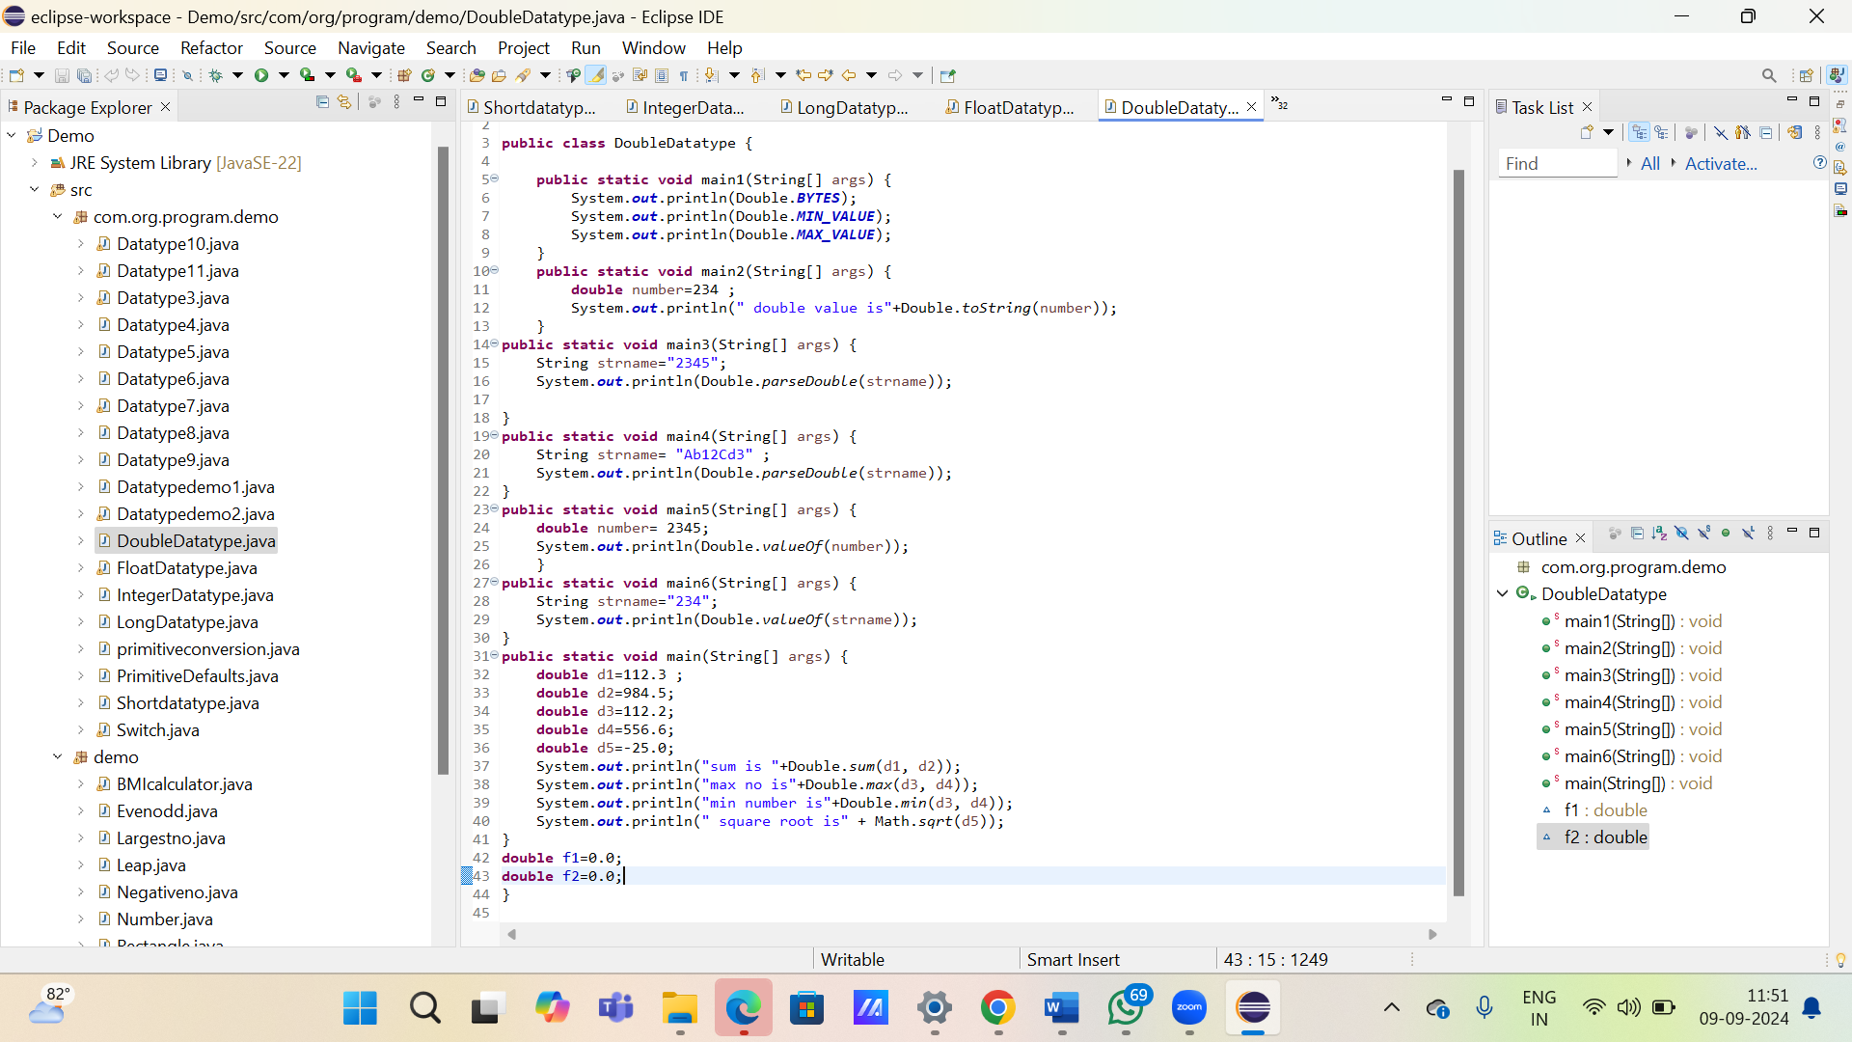

**8. Conversion between Primitive Types and Strings**

Initialize a variable of each primitive type with a user-defined value and convert it into String:

* + First, use the toString method of the corresponding wrapper class. (e.g., Integer.toString()).
  + Then, use the valueOf method of the String class. (e.g., String.valueOf()).

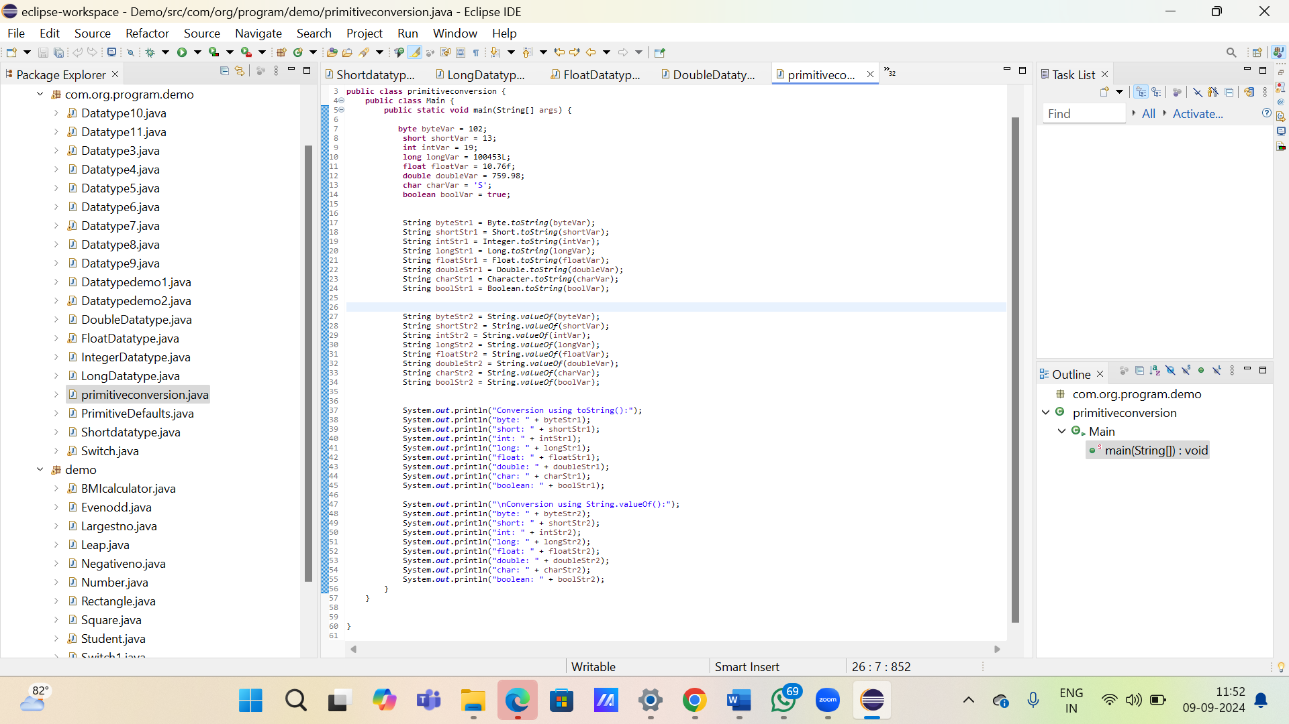

**9. Default Values of Primitive Types**

Declare variables of each primitive type as fields of a class and check their default values. (Note: Default values depend on whether the variables are instance variables or static variables).

**package** com.org.program.demo;

**public** **class** PrimitiveDefaults {

**byte** instanceByte;

**short** instanceShort;

**int** instanceInt;

**long** instanceLong;

**float** instanceFloat;

**double** instanceDouble;

**char** instanceChar;

**boolean** instanceBoolean;

**static** **byte** *staticByte*;

**static** **short** *staticShort*;

**static** **int** *staticInt*;

**static** **long** *staticLong*;

**static** **float** *staticFloat*;

**static** **double** *staticDouble*;

**static** **char** *staticChar*;

**static** **boolean** *staticBoolean*;

**public** **static** **void** main(String[] args) {

PrimitiveDefaults defaults = **new** PrimitiveDefaults();

System.***out***.println("Instance variable default values:");

System.***out***.println("byte: " + defaults.instanceByte);

System.***out***.println("short: " + defaults.instanceShort);

System.***out***.println("int: " + defaults.instanceInt);

System.***out***.println("long: " + defaults.instanceLong);

System.***out***.println("float: " + defaults.instanceFloat);

System.***out***.println("double: " + defaults.instanceDouble);

System.***out***.println("char: [" + defaults.instanceChar + "]");

System.***out***.println("boolean: " + defaults.instanceBoolean);

System.***out***.println("\nStatic variable default values:");

System.***out***.println("byte: " + *staticByte*);

System.***out***.println("short: " + *staticShort*);

System.***out***.println("int: " + *staticInt*);

System.***out***.println("long: " + *staticLong*);

System.***out***.println("float: " + *staticFloat*);

System.***out***.println("double: " + *staticDouble*);

System.***out***.println("char: [" + *staticChar* + "]");

System.***out***.println("boolean: " + *staticBoolean*);

}

}

**10. Arithmetic Operations with Command Line Input**

Write a program that accepts two integers and an arithmetic operator (+, -, *, /) from the command line. Perform the specified arithmetic operation based on the operator provided. (Hint: Use switch-case for operations).

**package** com.org.program.demo;

**public** **class** LongDatatype {

**public** **static** **void** main1(String[] args) {

System.***out***.println("long conversion is" +Long.***BYTES***);

System.***out***.println("min value"+Long.***MIN_VALUE***);

System.***out***.println("max value"+Long.***MAX_VALUE***);

}

**public** **static** **void** main2(String[] args) {

**long** number=1234456;

System.***out***.println("string is" +Long.*toString*(number));

}

**public** **static** **void** main3(String[] args) {

String strnumber="abcd";

System.***out***.println(Long.*parseLong*(strnumber));

}

**public** **static** **void** main4(String[] args) {

String strnumber="Ab12Cd3" ;

System.***out***.println(Long.*parseLong*(strnumber));

}

**public** **static** **void** main5(String[] args) {

**long** num=5678;

String num2="abcd";

System.***out***.println(Long.*valueOf*(num));

System.***out***.println(Long.*valueOf*(num2));

}

**public** **static** **void** main6(String[] args) {

**long** num=100;

**long** num1=200;

System.***out***.println(Long.*sum*(num, num1));

}

**public** **static** **void** main7(String[] args) {

**long** num1=1122;

**long** num2=5566;

System.***out***.println("min number"+Long.*min*(num1, num2));

System.***out***.println("max number"+Long.*max*(num1, num2));

}

**public** **static** **void** main(String[] args) {

**long** num=7;

System.***out***.println(Long.*toBinaryString*(num));

System.***out***.println(Long.*toOctalString*(num));

System.***out***.println(Long.*toHexString*(num));

}

}